CAR PARKING SYSTEM
VHDL SIMULATION LAB REPORT

1-) Title And Authors
Lab 1:Car Parking System (VHDL Simulation)
Course: Fundamentals of Electronics / Logic Networks
Authors:
- Francesco Bertaiola
- Stefano Giroletti
- Bekir Hamza Gumus

2-) Objectives and Specifications
The objective of this laboratory activity was to design, implement, and simulate a Car Parking Control System using VHDL and GHDL + GTKWave.
The system detects vehicle arrivals through sensors, processes password inputs, manages multiple cars, and displays appropriate messages on a 7-segment display.
The system must meet the following specifications:
- Asynchronous, active-low reset (reset_n = '0')
- Two digit passwords (password_1, password_2)
- Two entrance sensors: front_sensor, back_sensor
- Three LED indicators:
- Green LED → Successful entry
- Red LED → Wrong password or STOP condition
- 7-segment outputs:
- “En” → Wait for password
- “EE” → Wrong password
- “GO” → Correct password
- “SP” → STOP (Multiple cars)
- STOP mode is triggered when car 2 arrives before car 1 leaves.
The system must return to IDLE after each operation

3-) Block Diagram
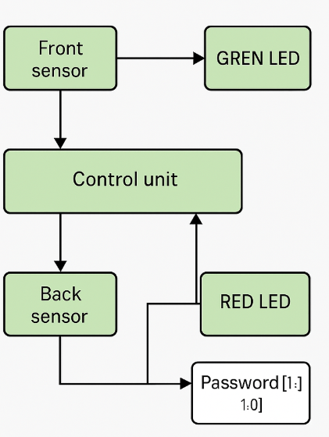
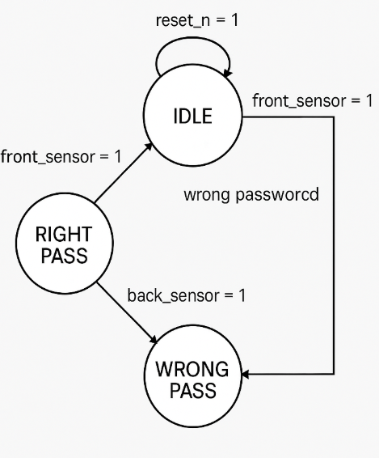
Main components:
- FSM (Finite State Machine) implementing IDLE, WAIT_PASSWORD, RIGHT_PASS, WRONG_PASS, and STOP
- Password Comparator
- Counter (10-cycle waiting time)
- 7-segment Encoder
- LED Controller
4-) Components Description
4.1 Finite State Machine (FSM)
Implements 5 states:
- IDLE
- WAIT_PASSWORD
- RIGHT_PASS
- WRONG_PASS
- STOP
- RESET state handling
Transitions depend on:
- Sensor inputs
- Password correctness
- Counter expiration
- passcode timeout
- reset signal
4.2 Counter
Counts 10 clock cycles during password waiting phase.
If the counter reaches 9, the system evaluates the password.
4.3 Password Comparator
Compares password_1 and password_2 with the expected value "01" / "10".
4.4 7-Segment Encoder
Converts symbolic outputs into 7-segment codes:
- E → 0000110
- N → 0101011
- G → 0000010
- O → 1000000
- S → 0100100
- P → 0001100
- All off → 1111111
4.5 LED Driver
- Green LED blinks during RIGHT_PASS
- Red LED blinks during WRONG_PASS and STOP
s
4.6 Timeout Trigger (pswd_in Signal)
This signal is asserted (pswd_in = '1') when the user begins entering the password.
If no correct password is provided within the 10-cycle waiting window, the counter expires and pswd_in automatically returns to '0'.
5-) Simulation and Results
Simulations were performed using GHDL and visualized in GTKWave.
All scenarios required in the laboratory instructions were successfully reproduced.
5.1 Scenario 1 — Normal Entry
Description:
A car arrives (front_sensor='1').
After a 10-cycle waiting time, a correct password ("01", "10") is provided.
The system displays “GO”, green LED blinks, and after back_sensor='1', the system returns to IDLE.
Waveform Evidence: (0 - 1.2 us )
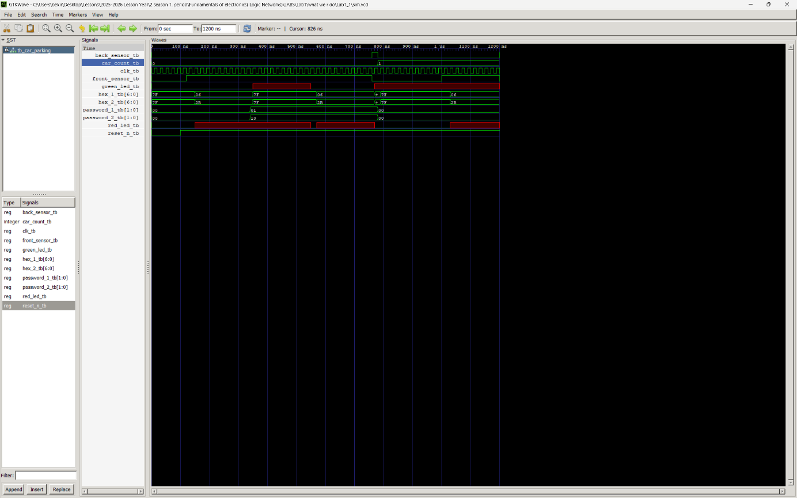
Key observations:
- front_sensor='1' → FSM enters WAIT_PASSWORD
- Counter counts from 0 to 9
- Correct password triggers RIGHT_PASS
- hex_1="0000010", hex_2="1000000" → “GO”
- System returns to IDLE when back_sensor='1'.

5.2 Scenario 2 — Wrong Password
Description:
A car arrives but enters an incorrect password ("00", "00").
The system enters WRONG_PASS, displays “EE”, and the red LED blinks.
A correct password is then entered to exit the error state.
Waveform Evidence: (1.1 – 2.1 us )
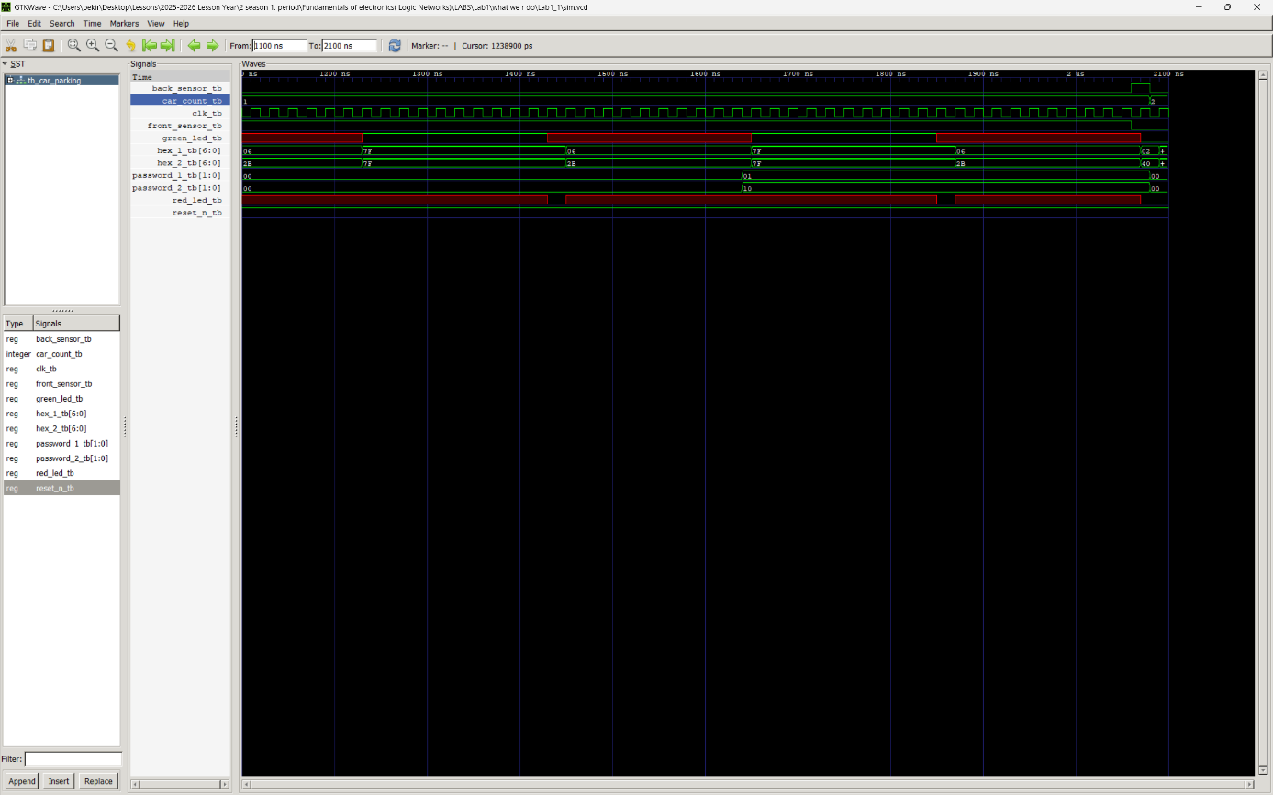
Key observations:
- During WAIT_PASSWORD, wrong password applied
- Display shows “EE”
- red_led toggles
- Correct password transitions system to RIGHT_PASS

5.3 Scenario 3 — Multiple Cars (STOP State)
Description:
Car 1 enters with correct password (RIGHT_PASS).
Before Car 1 leaves (back_sensor='1'), Car 2 arrives (front_sensor='1').
The system enters STOP, displaying “SP”, and blinking the red LED.
Waveform Evidence: (2 – 3.2 us )
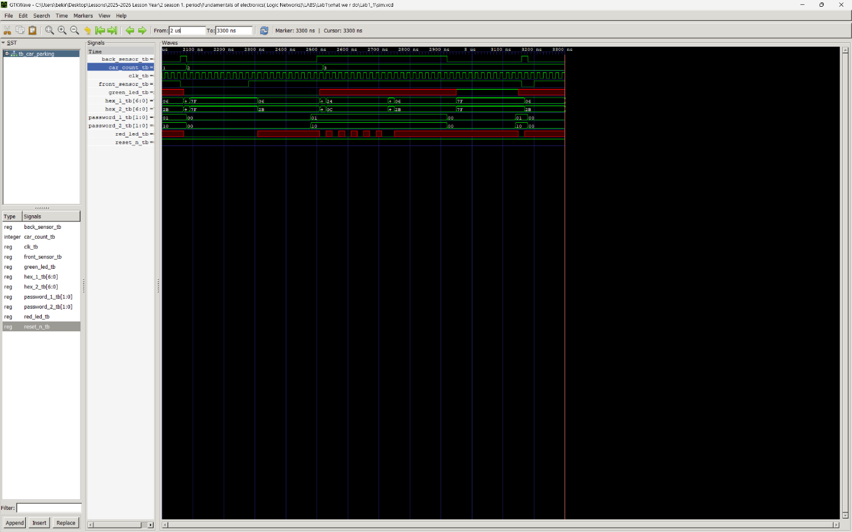
Key observations:
- Car 1 RIGHT_PASS → GO
- front_sensor='1' and back_sensor='1' simultaneously
- FSM enters STOP
- hex_1="0100100", hex_2="0001100" → “SP”
- After Car 1 leaves (back_sensor='0'), Car 2 can enter normally

5.4 Scenario 4 — Reset
Description:
When reset_n='0' is asserted, the system must immediately return to IDLE regardless of its current state.
Waveform Evidence: (3.15 – 3.4 us )
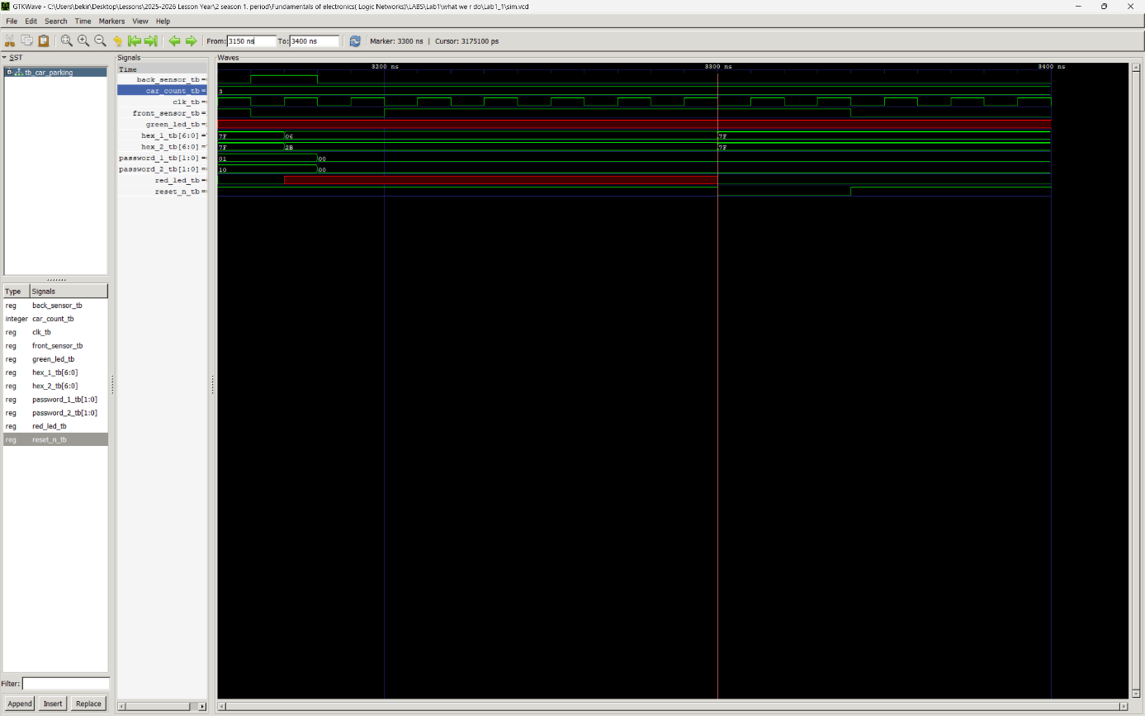
Observations:
- All outputs reset to default
- Display turns off (1111111)
- LED outputs go low
- FSM re-enters IDLE

6-) Credits
This project was developed by the group using:
- Course material provided by instructor Philippe Velha
- VHDL inspired by lecture materials
Simulation Tools :
- GTKWave screenshots generated by the group
- External diagrams/tools referenced: Antares

